Title Page
Event Ease POE: Reflective Report
Student Name: Qhawe Kheswa
Student Number: ST10443092
Date: 18 June 2025
Course: CLDV6211
Application Link: https://st10443092-akf9cccygvcngjc8.eastus-01.azurewebsites.net/
Git Link: https://github.com/VCPTA/bca2-cldv6211-portfolio-of-evidence-poe-submission-ST10443092.git

Contents
Introduction & Project Overview 2
System Features & Requirements 3
Azure Component Discussion 4
Technology Stack & Tools 4
Reflection on the Development Process 5
Reflection on Cloud Design & Architecture 6
Azure Screenshots 7
Conclusion & References 7
References 8

Introduction & Project Overview

Introduction
Event Ease is a web-based event management system developed using the ASP.NET MVC framework and deployed on Microsoft Azure. The purpose of the system is to streamline the process of managing bookings, events, and venue availability.
Purpose of the Reflective Report
This report documents the development journey of the Event Ease POE project. It reflects on the technical decisions, tools, challenges, and lessons learned throughout the process, especially focusing on the use of Azure cloud services.
Azure Services Used
Azure Web App for hosting the frontend and backend services
Azure SQL Database to manage structured data like users, events, and bookings
Azure Blob Storage for managing images and supporting documents
This report Looks at these areas
- A breakdown of the system's core features and their alignment with user needs
- An analysis of Azure components used
- Discussion of the technology stack and development tools
- Reflections on the development process and cloud architecture
- Conclusions and suggestions for future improvements

System Features & Requirements

Feature | Description | How It Works
User Registration | Allows users to create accounts | Data stored in Azure SQL; validations in MVC
Event Management | Admin can add/edit/delete events | CRUD operations linked to Azure SQL
Booking System | Users can book events and can look at a Summary | Stores bookings with event & venue reference
Venue Availability | Filters out unavailable venues on selected dates | LINQ queries validate time slots
Event Type Filter | Filter events by category (e.g., music, sports) | Dropdown filter connected to backend query
Admin Dashboard | Manages users, events, and bookings | Role-based access, secured with auth filters
Search Function | Users can search by event name or venue | Case-insensitive search using LINQ in controller

Feature Relevance
These features align with the primary system goals: providing a seamless user experience for event discovery and management while giving admins control over operations. The use of filtering and validation improves usability and efficiency.

Azure Component Discussion

Azure Web App
Chosen for its seamless deployment from GitHub and integration with .NET applications. It offers easy scaling and built-in monitoring. A challenge encountered was configuring environment variables for production builds.
Azure SQL Database
Used for relational data storage due to its compatibility with Entity Framework and strong query capabilities. It ensures data consistency. An issue arose during initial deployment due to connection string misconfiguration.
Azure Blob Storage
Used for storing images and user-uploaded documents. It supports unstructured data and integrates easily with the backend. The challenge was setting correct container permissions and generating secure access URLs.
Alternative Services
Firebase could serve as a NoSQL alternative for faster development, and AWS S3 offers a similar storage solution to Blob Storage. However, Azure provided better native integration with the .NET stack.

Technology Stack & Tools

Frontend: HTML, CSS, Razor Views
Razor Pages were used for templating with built-in server-side rendering.
Backend: ASP.NET Core MVC
Provided a structured and testable framework with built-in routing.
Database: Azure SQL with Entity Framework Core
Simplified CRUD operations through code-first migrations.
Storage: Azure Blob Storage
Enabled media file hosting with secure access.
Tools Used:
Visual Studio – Main IDE for development
GitHub – Version control
Azure Portal – Service management and resource deployment
These tools were selected for compatibility, efficiency, and the ability to support a professional development workflow.

Reflection on the Development Process

Personal Experience
Building Event Ease POE was a challenging but ended up being a rewarding experience when I saw the final product. I improved my understanding of both front and back end development and cloud service integration.

Challenges Encountered
Handling deployment errors when publishing to Azure Web App due to using deleted resources and having to update them
Dealing with data validation across front and back end
Setting up blob storage permissions correctly.

Lessons Learned
Importance of debugging deployment pipelines and connection strings
Using Entity Framework migrations effectively
Structuring a scalable MVC application
Cloud storage is not just about storing data, but also about securing user access but software access such as integrating blob and sql and being able to allow both to interact
Growth Areas
This project deepened my understanding of asynchronous operations, LINQ queries, and authentication strategies. This also taught me that you will achieve your goal/ the applications goal easier and quicker if you plan your work beforehand instead of planning as you go along

Reflection on Cloud Design & Architecture

Understanding Cloud Architecture
Initially, my view of cloud computing was limited to hosting. Through this project, I learned about scalability, cost management, and data persistence.

Scalability
Azure Web App’s scaling capabilities allow the system to handle more traffic without architectural changes.

Security
Azure's role-based access and connection strings help safeguard user data. I learned to manage secrets securely using App Service settings.

Deployment Pipelines
While I did not fully implement GitHub Actions, I began experimenting with automatic deployment triggers, which I plan to improve in future versions.

Architectural Improvements
I would introduce a more layered architecture with a service layer to improve maintainability and perhaps integrate Azure Functions for background tasks.

Azure Screenshots
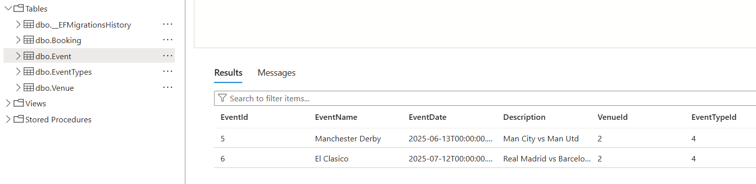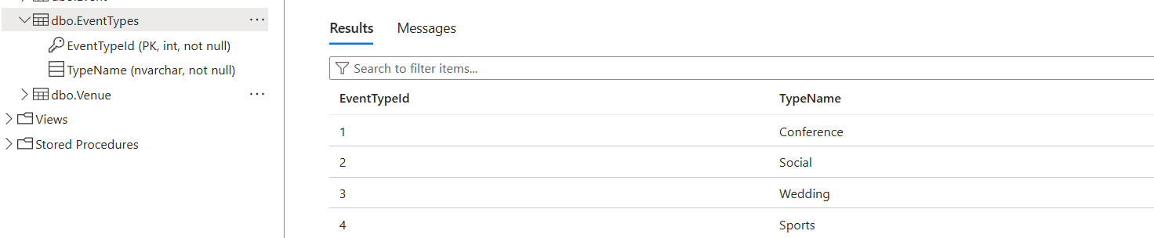

Conclusion & References

Conclusion
The development of Event Ease has been a valuable learning experience. I taught myself hands-on experience with MVC architecture, Azure services, and deploying a full-stack web app. The project highlighted the power and challenges of cloud-based development.
Final Thoughts
Azure’s integrated tools made deployment and data management efficient. However, understanding resource permissions and managing deployments require attention. Future improvements include using Azure DevOps pipelines and introducing automated testing.

References

Microsoft. (2023). What is Azure App Service? [Online]. Available at: https://learn.microsoft.com/en-us/azure/app-service/ [Accessed 15 Jun. 2025].
Microsoft. (2023). Azure SQL Database documentation. [Online]. Available at: https://learn.microsoft.com/en-us/azure/azure-sql/ [Accessed 15 Jun. 2025].
Microsoft. (2023). Introduction to Azure Blob Storage. [Online]. Available at: https://learn.microsoft.com/en-us/azure/storage/blobs/ [Accessed 15 Jun. 2025].
Liberty, J. (2019). Programming C# 8.0. O'Reilly Media.
Price, J. (2021). Learn ASP.NET Core MVC. Apress.

